Crypto Prediction with LSTM, GRU and Bidirectional LSTM

Abstract:
Accurate prediction of cryptocurrency prices remains a challenging task due to the inherent nonlinearity of the market. This study addresses this challenge by proposing and evaluating three Recurrent Neural Network (RNN) models: Long Short-Term Memory (LSTM), Gated Recurrent Unit (GRU), and Bi-Directional LSTM (Bi-LSTM) for predicting the exchange rates of three major cryptocurrencies—Bitcoin (BTC), Binance (BNB), and Ripple (XRP). The performance of these models is assessed using Root Mean Squared Error (RMSE) and Mean Absolute Percentage Error (MAPE).
Experimental results demonstrate that the Bi-LSTM model consistently outperforms LSTM and GRU in predicting cryptocurrency prices. Specifically, Bi-LSTM exhibits superior accuracy with MAPE values of 1.82%, 2.00%, and 2.63% for BTC, BNB, and XRP, respectively. This study suggests Bi-LSTM as the preferred algorithm for cryptocurrency price prediction, offering valuable insights for investors and researchers.
The findings indicate that the proposed prediction models hold promise for practical application in cryptocurrency investment and trading. Furthermore, the paper recommends future research to explore additional factors influencing cryptocurrency prices, including social media and trading volumes.
Keywords: machine learning; artificial neural network; deep learning; cryptocurrency.

1. Introduction
The contemporary financial landscape is undergoing a transformative shift, challenging the traditional monetary system dominated by fiat currencies. While fiat currency boasts attributes like divisibility, transferability, durability, and scarcity, inherent drawbacks such as the lack of tangible backing and centralized control have led to issues like hyperinflation and income inequality. The susceptibility of current transaction ledgers to manipulation and the dependence on intermediaries further underscore the need for a more secure and transparent financial system.
Historically, instances of trust breaches, such as the dot-com bubble in the 1990s and the real estate crisis in 2008, have eroded confidence in the traditional financial system. In response to these challenges, blockchain technology emerged as a revolutionary system in October 2008, introducing the first digital currency, Bitcoin (BTC). This decentralized system enables peer-to-peer monetary transactions over the public internet, eliminating the need for intermediaries and gaining recognition as a significant asset class globally.
Cryptocurrencies, characterized by their independence from traditional banks and reliance on cryptography for transaction security, represent a novel form of digital currency. Bitcoin, Ethereum (ETH), Litecoin (LTC), Binance Coin (BNB) and Ripple (XRP) are among the most prominent cryptocurrencies in the market. Ethereum stands out for its blockchain platform that supports smart contracts and decentralized applications, while Litecoin prioritizes transaction speed. Ripple, on the other hand, distinguishes itself by its focus on facilitating cross-border payments.
This dynamic landscape has prompted extensive research into cryptocurrency price prediction, a critical aspect for investors and speculators seeking to navigate the highly volatile market. Traditional financial forecasting models face challenges due to the complexity and nonlinear behavior of cryptocurrency prices, influenced by factors such as government policies, technological advancements, public perception, and global events.
In response to these challenges, this study proposes the application of deep learning algorithms, specifically Long Short-Term Memory (LSTM), Gated Recurrent Unit (GRU), and Bi-Directional LSTM (Bi-LSTM), to improve the accuracy of cryptocurrency price predictions. The primary objective is to identify concealed patterns in historical data, harnessing the power of artificial intelligence and deep learning to generate reliable predictions for BTC, Binance (BNB), and Ripple (XRP).
This research aims to answer key questions: How can AI and DL algorithms enhance the ability of investors and speculators to forecast cryptocurrency prices? What is the most effective artificial neural network model for predicting the chosen cryptocurrencies' prices?
The structure of this paper includes a literature review in Section 2, followed by a detailed description of the materials and methodology in Section 3. Section 4 presents the experimental results, while Section 5 offers a relative comparison with similar studies. Finally, Section 6 summarizes the conclusions drawn from the study, providing insights into the evolving landscape of cryptocurrency price prediction.

2. Literature Review
Machine learning, a subset of artificial intelligence, has gained prominence as a valuable tool for predicting future trends by leveraging historical data. In the realm of cryptocurrency, where market dynamics are complex and nonlinear, the application of machine learning models has shown promise in enhancing forecasting accuracy. Previous studies highlight the advantages of machine learning techniques over traditional forecasting models, emphasizing their ability to approximate or even match actual results.
Various machine learning techniques, including decision trees, support vector machines (SVM), and neural networks (NN), have been employed to predict cryptocurrency prices. Research by [12] demonstrated the effectiveness of SVM in forecasting the prices of Bitcoin (BTC), Ethereum (ETH), Litecoin (LTC), Ripple (XRP), and Stellar. The inclusion of cryptocurrencies in multi-asset portfolios has been shown to improve portfolio effectiveness, reducing standard deviation and increasing the Sharpe ratio [13].
Several studies have delved into the use of machine learning algorithms for BTC price forecasting. [14] utilized linear regression to outperform other methods, while [15] explored ensemble methods combining artificial neural networks (ANN), k-nearest neighbors (KNN), and gradient-boosted trees for predicting nine different cryptocurrencies. The consensus in these studies is that ensemble models often outperform individual techniques.
The advent of deep learning, a subset of machine learning involving the training of artificial neural networks (ANN) on large datasets, has brought about significant advancements. Recurrent Neural Networks (RNNs), such as Long Short-Term Memory (LSTM) and Gated Recurrent Unit (GRU), have proven effective in processing sequential data like time series. [17] employed a two-stage approach using ANN, Random Forest (RF), and LSTM to forecast BTC prices, demonstrating the superiority of the LSTM model over traditional methods. A hybrid method combining LSTM and GRU networks exhibited higher accuracy in predicting the prices of Litecoin (LTC) and Monero (XMR) [18].
In recent studies, researchers have explored novel approaches to improve the accuracy of cryptocurrency price prediction. [22] introduced the Weighted and Attentive Memory Convolutional Neural Network (WAMC), combining GRU, channel-wise weighting, and CNN modules. This innovative model achieved promising results in predicting the prices of Ethereum (ETH) and Bitcoin (BTC).
While machine learning and deep learning models show potential, the evolving nature of the cryptocurrency market necessitates continuous exploration and refinement of these approaches. This study contributes to the growing body of literature by proposing the application of Bi-Directional LSTM (Bi-LSTM) alongside LSTM and GRU for predicting the prices of Bitcoin, Binance, and Ripple. The subsequent sections detail the materials, methodology, and experimental results, offering insights into the comparative performance of these models in the context of cryptocurrency price prediction.

3. Materials and Methods
This section delineates the methodologies employed in the preprocessing and modeling phases of the research. It encompasses a detailed description of the dataset collection, the application of deep learning models such as LSTM, GRU, and Bi-LSTM, hyperparameter tuning, and the metrics used for performance evaluation. The primary objective is to predict the prices of three cryptocurrencies: Bitcoin (BTC), Binance (BNB), and Ripple (XRP). The study adheres to a systematic process involving historical data collection, exploratory data visualization, dataset partitioning into training and testing sets, model training, testing, and a comprehensive comparison of the performance of each deep learning method. The subsequent sections provide a step-by-step account of these procedures, offering insights into the predictive capabilities of the selected models for cryptocurrency price forecasting.

3.1. Dataset
In this study, a five-layer network architecture was proposed for each deep learning model, comprising four Recurrent Neural Network (RNN) layers and a fifth Dense layer. The layer configurations included 50 neurons in the first layer, 80 neurons in the second and third layers, 50 neurons in the fourth layer, and a Dense layer with one neuron for LSTM, Bi-LSTM, and GRU models.
The dataset underwent a series of pre-processing steps, as illustrated in Figure 1. Fortunately, the cryptocurrency data exhibited no missing values, allowing us to proceed directly to reshaping. Reshaping was performed to align the data with the requirements of LSTM, Bi-LSTM, and GRU models. Ensuring the accuracy of model fitting and preventing bias, feature-wise normalization techniques—specifically, MinMax Scaling—were applied before model training. Recent studies have highlighted the efficacy of such scaling methods in improving model performance [23].
To maintain the integrity of features for each cryptocurrency, we adopted an 80:20 training-to-testing split strategy. The dataset spans from January 1, 2018, to October 8, 2023. The training set comprises 80% of the data, ensuring continuity in features, while the remaining 20% forms the testing set.
Python 3 and relevant libraries, including NumPy, Pandas, Matplotlib, scikit-learn, and Tensorflow Keras, were employed for the experimental procedures. The model training and execution took place on a Google Colab notebook with GPU acceleration. Core Python libraries such as NumPy for numerical computing, Pandas for data processing and analysis, Matplotlib for data visualization, scikit-learn for data preprocessing, and TensorFlow Keras for deep learning API were utilized to conduct the experiments.

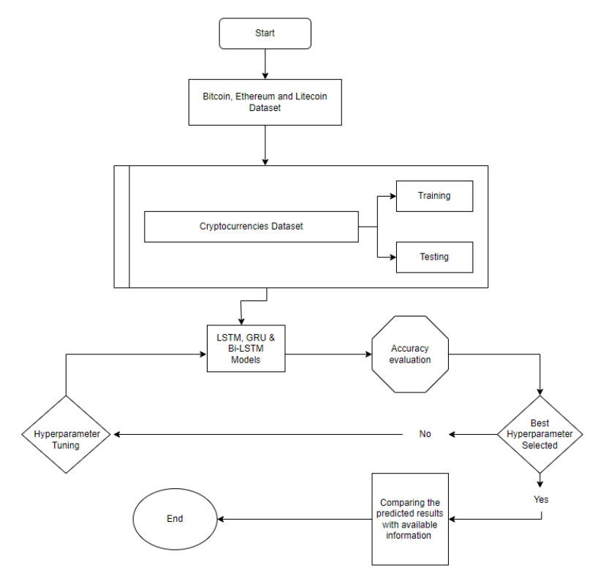
Figure 1. Methodology of processing data and model selection.
Figures 2–4 provide visual representations of the daily closing prices for the specific cryptocurrencies under examination: BTC, BNB, and XRP. The datasets are distinctly segmented into training and testing sets, facilitating a clear understanding of the temporal distribution of cryptocurrency prices over time. It is essential to highlight that the historical data considered for analysis spans the last five years, strategically excluding earlier periods to filter out potentially monotonous data in the early days of cryptocurrency existence. This focused dataset ensures relevance and accuracy in training and evaluating the deep learning models for cryptocurrency price prediction.
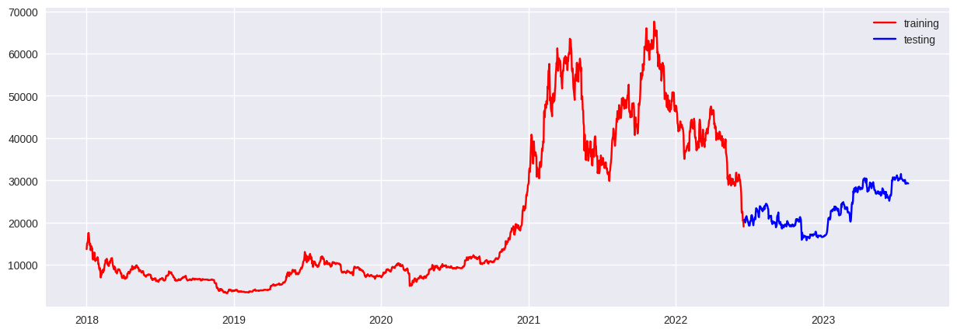
Figure 2. Training and Test sample for BTC.
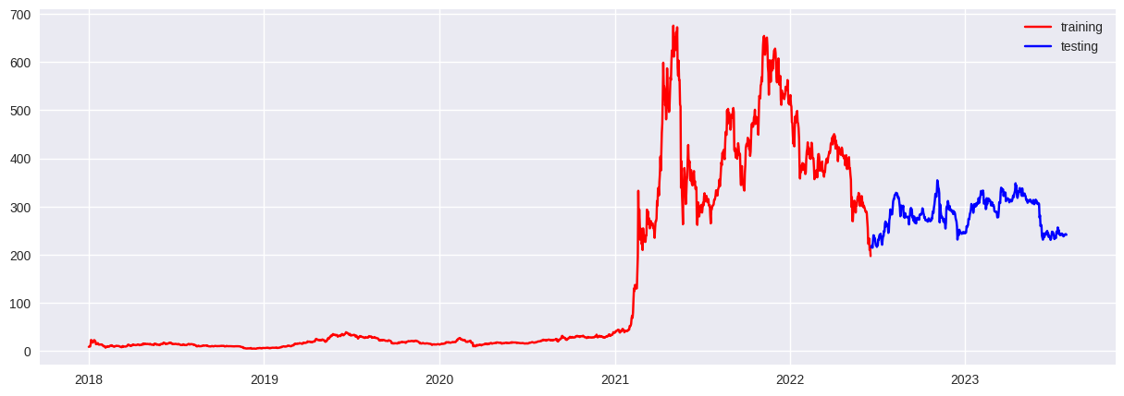
Figure 3. Training and Test sample for BNB
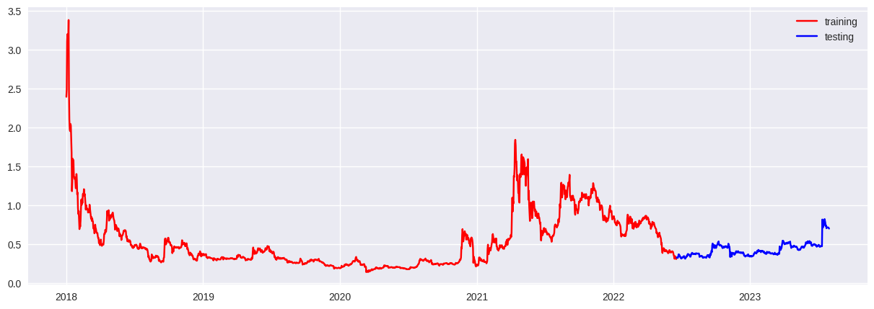
Figure 3. Training and Test sample for XRP
The dataset used in this study was collected through the Yahoo Finance Python API, yfinance. Leveraging this API facilitated the retrieval of accurate and up-to-date historical data for Bitcoin (BTC), Binance (BNB), and Ripple (XRP). The utilization of yfinance aligns with best practices in acquiring cryptocurrency data for research and analysis.

3.2 Deep learning Algorithms

3.2.1. Long Short-Term Memory—LSTM
Long Short-Term Memory (LSTM) represents a significant advancement over traditional Recurrent Neural Networks (RNNs). Designed to address long-term dependence issues and overcome the vanishing gradient problem, LSTM incorporates a unique mechanism for regulating information flow, allowing for the retention of information over extended periods [24]. The architecture of an LSTM comprises memory blocks, recurrently connected sub-networks that serve the dual functions of maintaining the network's state over time and controlling the flow of information between cells. Figure 8 illustrates the LSTM block architecture, depicting input signals (xt), output states (ht), and the activation function.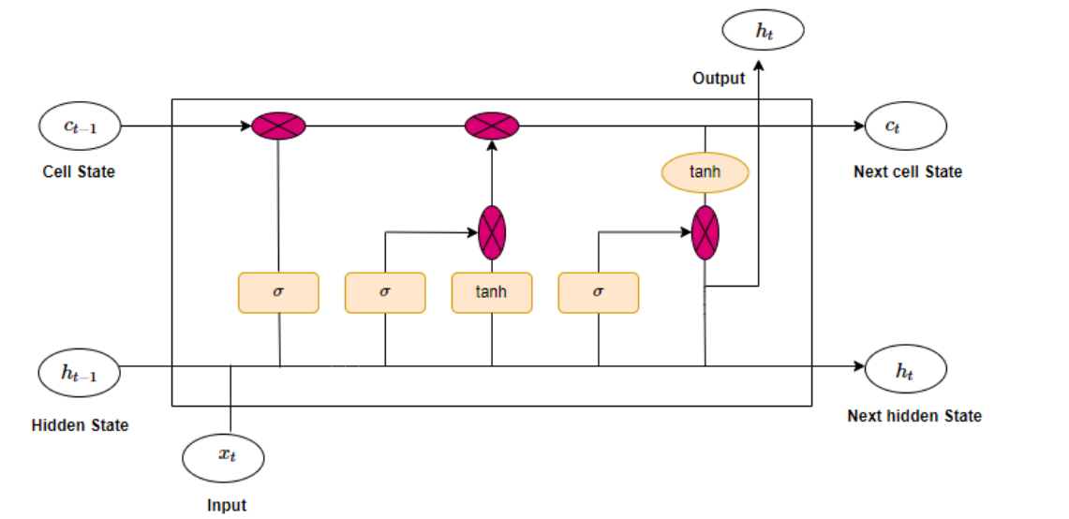
Figure 8. The structure of a long short-term memory (LSTM) algorithm.
The LSTM's forward training process can be described through a set of equations [25]:
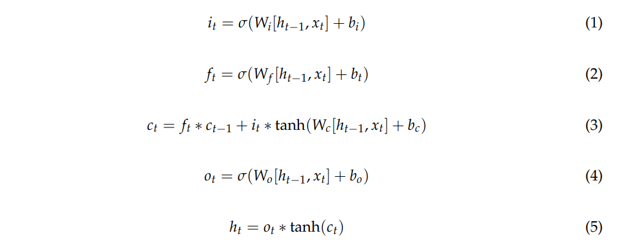
where xt is the input at time step t, ht is the hidden state at time step t, ct is the cell state at time step t, and it , ft , and ot are the input gate, forget gate, and output gate, respectively, at time step t. W and b are the weight matrices and bias vectors, respectively. The sigmoid function and the hyperbolic tangent function (tanh) are used to bound the output between 0 and 1, and between –1 and 1, respectively

3.2.2 Gated Recurrent Unit (GRU)
Gated Recurrent Units (GRUs) represent a variant of Recurrent Neural Networks (RNNs) introduced in 2014 as an enhancement over traditional LSTM networks [26]. While sharing the capability to process input sequences of varying lengths and maintain a state encoding past information, GRUs differ from LSTMs in their simplified architecture. Instead of utilizing multiple gates and an internal memory cell, GRUs employ a single update gate to determine retained information and a reset gate to decide which information to discard. This streamlined design contributes to easier training while still achieving comparable performance across various tasks [27].
Research by [26] demonstrated GRUs outperforming LSTMs in language modeling on the Penn Treebank dataset. In a broader comparison of Natural Language Processing (NLP) models by [28], GRUs proved competitive with LSTMs and Convolutional Neural Networks (CNNs) on multiple benchmarks. A notable advantage of GRUs is their effectiveness in capturing long-range dependencies in sequential data, surpassing simple RNNs. The update and reset gates allow GRUs to selectively retain or discard information based on the current input and network state, making them well-suited for tasks requiring the utilization of information from extended sequences, such as language translation.
In Figure 9, the hidden state at time t, ht , is updated based on the input at time t, xt , and the previous hidden state, ht−1, using the following equations [29]:
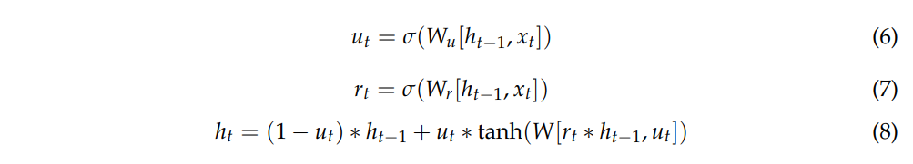
where ut and rt is update and reset gate, respectively.
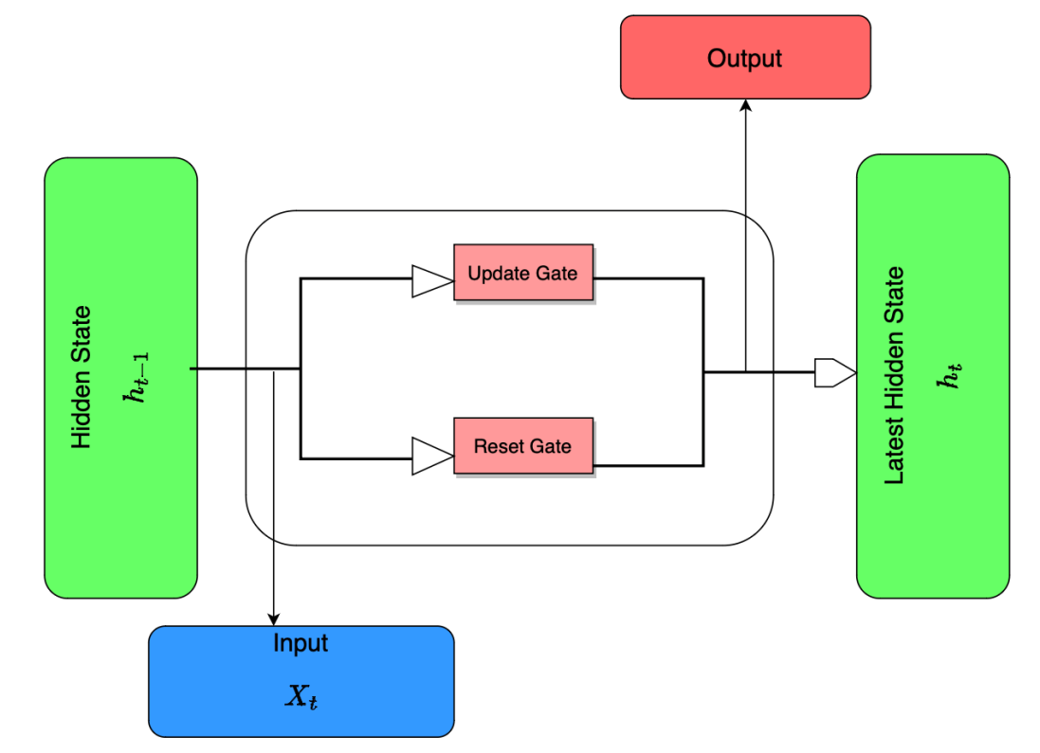
Figure 9. The diagram of a GRU cell.

3.2.3 Bi-Directional LSTM
Bi-Directional Long Short-Term Memory (Bi-LSTM) or bidirectional Gated Recurrent Unit (Bi-GRU), as illustrated in Figure 10, represents a type of Recurrent Neural Network (RNN) that processes sequential data in both forward and backward directions. This bidirectional processing allows the network to leverage information from both past and future data points when making predictions or classifications. This bidirectional approach is particularly advantageous for tasks where the context of the current time step depends on both preceding and succeeding events.
In a Bi-LSTM or Bi-GRU, two layers of LSTM or GRU cells are stacked together. One layer processes the data in the forward direction, while the other processes the data in the backward direction. The concept of Bi-LSTMs was first introduced in the paper "Bi-directional Recurrent Neural Networks" [30] in 1997, where the authors proposed using both forward and backward LSTMs to model past and future context for speech signal processing tasks. Since then, Bi-LSTMs have found widespread applications in various natural language processing tasks, including language translation, sentiment analysis, and text classification. Moreover, Bi-LSTMs have demonstrated effectiveness in time series prediction across multiple studies [27,31,32], showcasing their capability to achieve successful results in diverse domains. Similarly, references [25,33] have employed Bi-LSTM and highlighted its powerful performance specifically in the context of time series data, further emphasizing its utility in cryptocurrency price prediction scenarios.
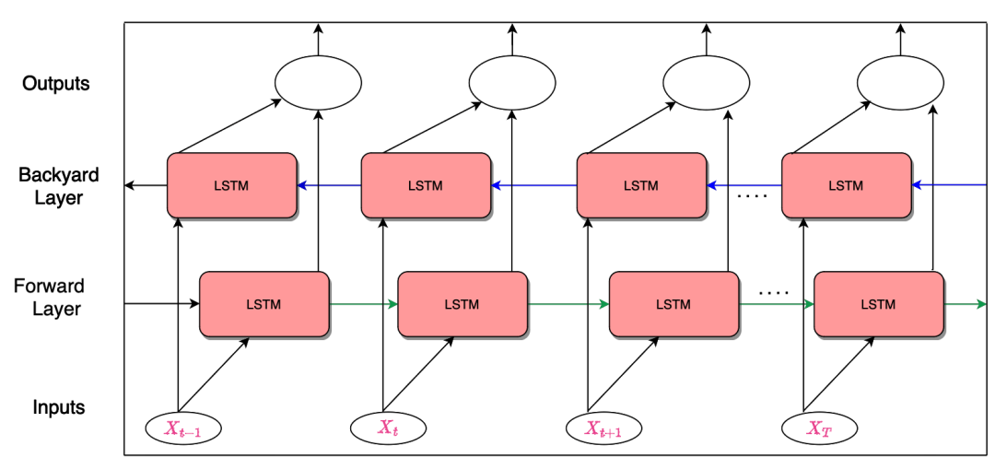
Figure 10. The structure of a bi-directional LSTM (Bi-LSTM) algorithm.

3.3 Hyperparameter Tuning
Hyperparameter tuning is a crucial aspect that significantly influences the effectiveness of a machine learning algorithm. Optimal hyperparameter selection can substantially enhance the algorithm's performance, leading to more accurate predictions [34]. The process of tuning hyperparameters before the final execution of the deep learning algorithm is vital for ensuring optimal results. In this study, key hyperparameters considered for optimization include the number of neurons in each layer, epoch size, and batch size.
- Number of Neurons in Each Layer: The architecture of the deep learning models involves multiple layers, and the number of neurons in each layer is a critical hyperparameter. This study explores various configurations to determine the optimal number of neurons in each layer for improved model performance.
- Epoch Size: An epoch represents a complete forward and backward pass of the entire dataset during the model's execution. The epoch size is a hyperparameter influencing the training duration and convergence. Different epoch sizes ranging from 50 to 1200 were experimented with, and the optimal epoch size was determined based on achieving the best results.
- Batch Size: The batch size refers to the number of samples used in one forward/backward pass. It plays a crucial role in model performance and training time. Various batch sizes, including 16, 32, 64, and 120, were tested during the experiments. The selection of an appropriate batch size involves a trade-off between more frequent weight updates and computational demands. In this study, 64 was identified as the optimal batch size, as it consistently produced more accurate results for all prediction models.
The hyperparameter tuning process aims to strike a balance between model accuracy, training time, and computational efficiency. Through systematic experimentation, the study identified the most effective hyperparameter configurations to ensure optimal deep learning model performance in predicting cryptocurrency prices.

3.4 Performance Metrics
To assess the effectiveness of the proposed Deep Learning (DL) algorithms, we employed two key performance metrics: Root Mean Squared Error (RMSE) and Mean Absolute Percentage Error (MAPE). These metrics serve as quantitative measures to evaluate the accuracy and reliability of the prediction models. Lower RMSE and MAPE values indicate superior performance in predicting cryptocurrency prices.
- Root Mean Squared Error (RMSE): RMSE is a commonly used metric that measures the average magnitude of the differences between predicted and actual values. It is calculated as the square root of the mean of the squared differences between forecasted (Pt) and actual (At) values over a specified number of time steps (n). The formula is given by:
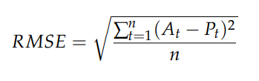
where Pt and At are the forecast and actual value, respectively, and n is the number of time steps.
- Mean Absolute Percentage Error (MAPE): MAPE is a percentage-based metric that quantifies the average percentage difference between predicted and actual values. It is calculated as the mean of the absolute percentage errors over the specified number of time steps (n). The formula is given by:
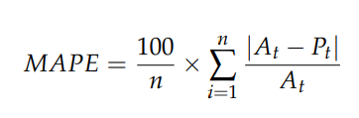
where Pt and At are the forecast and actual value, respectively, and n is the number of time steps.
These performance metrics provide a comprehensive evaluation of the predictive accuracy of the DL algorithms, enabling a comparative analysis of their effectiveness in forecasting cryptocurrency prices.

4. Results
In this section, we present the outcomes of the implemented deep learning models, utilizing Python libraries such as Sklearn, Keras, and Tensorflow. The algorithms were executed on a Colab notebook with GPU acceleration to enhance computational efficiency. The results for predicting cryptocurrency prices, specifically for BTC, BNB, and XRP, are detailed in Table 2. The model exhibiting the smallest error values is identified as the most effective. The comparison between actual and predicted values for these currencies is visually represented in Figures 11–19, illustrating the closeness between predicted and actual values with observable variations. A detailed breakdown of the performance metrics is provided in Table 2, offering insights into the predictive accuracy of each model.
Table 2. Performance results for the proposed models.
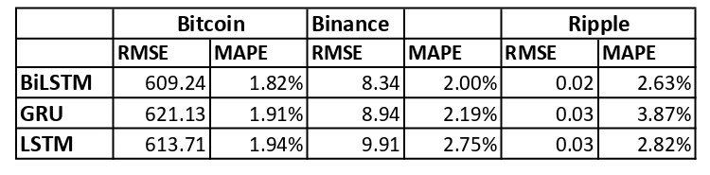

4.1. Results for BTC
As per the findings in Table 2, the Bi-LSTM model emerges as the most adept predictor for BTC prices, exhibiting the lowest RMSE and MAPE values. This assertion is corroborated by Figure 11, where the predictions from the Bi-LSTM model align closely with the actual prices. The outcomes imply that the Bi-LSTM model outperforms both LSTM and GRU in forecasting BTC trends, with a marginal performance gap compared to the LSTM model. The LSTM model secures the second-best performance for BTC, albeit with slightly higher RMSE and MAPE values. These results highlight the enhanced efficacy of bidirectional RNN networks in predicting BTC prices compared to their traditional RNN counterparts. The comparative visualization of actual and predicted values for the training dataset across the three models is presented in Figures 11–13 for BTC.

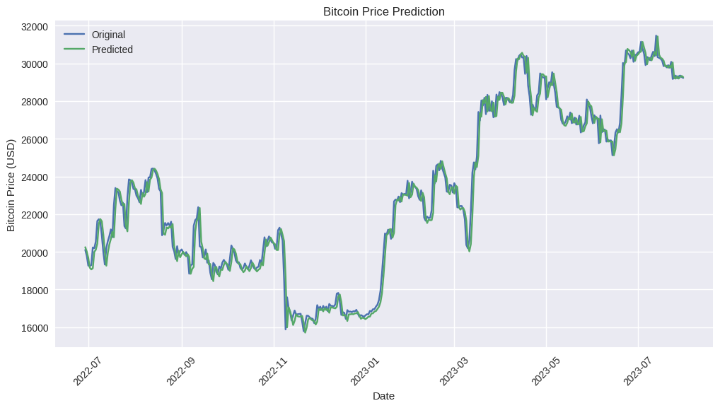
Figure 11. BTC—actual and predicted results using Bi-LSTM model.
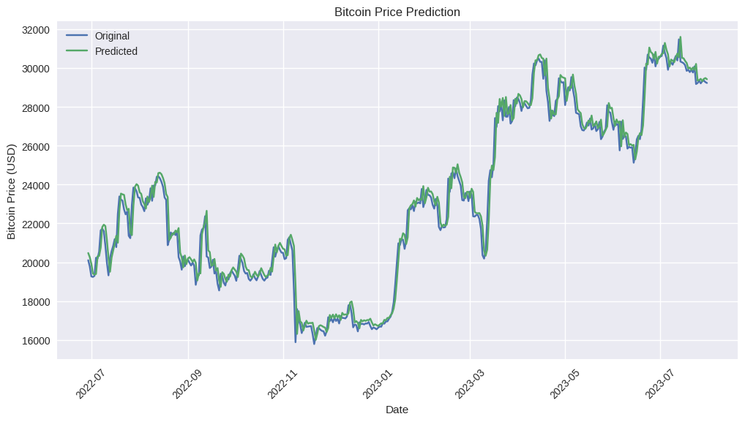
Figure 12. BTC—actual and predicted results using the LSTM model
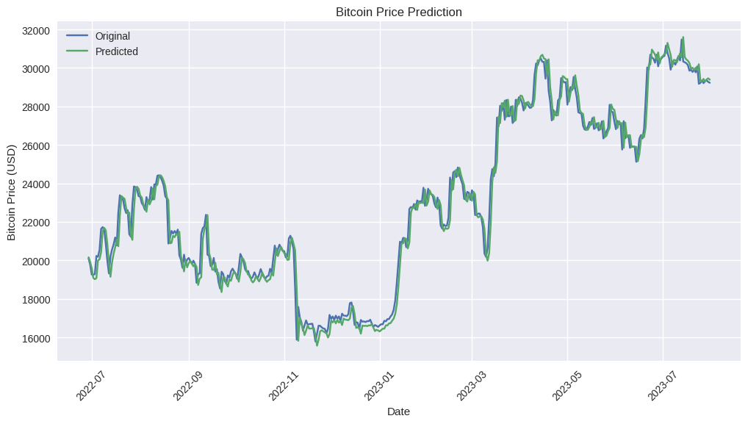
Figure 13. BTC—actual and predicted results using the GRU model.

4.2. Results for BNB
The evaluation results presented in Table 2 and Figure 14 indicate that the Bi-LSTM model stands out as the most proficient predictor for BNB prices. It achieves the lowest RMSE and MAPE values, namely 8.34 and 2.00%, respectively. Figure 14 visually underscores the Bi-LSTM model's accuracy, showcasing minimal discrepancies between the actual and predicted BNB prices. Additionally, Figure 15 illustrates the commendable performance of the GRU model, with a low MAPE of 2.19% and RMSE of 8.94, suggesting a high level of accuracy in its predictions for BNB prices. In contrast, Figure 16 depicts the comparison between actual and predicted prices of BNB using the LSTM model, which exhibits a slightly lower accuracy with a MAPE of 2.75% and RMSE of 9.91 compared to GRU and Bi-LSTM. In summary, bidirectional RNN networks, particularly Bi-LSTM, exhibit superior forecasting capabilities for BNB prices compared to traditional LSTM and GRU networks.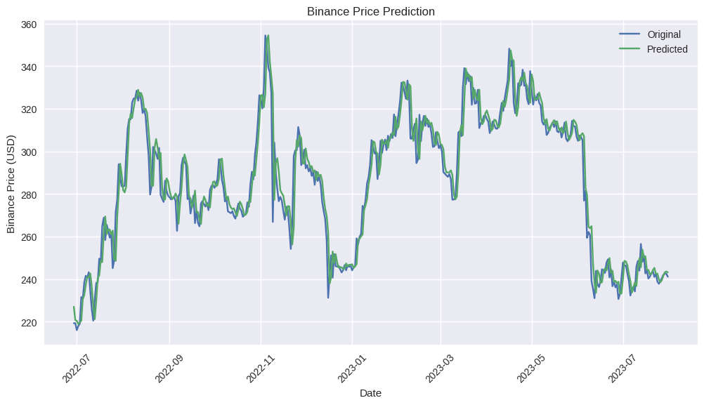
Figure 14. ETH—actual and predicted results using the Bi-LSTM model.
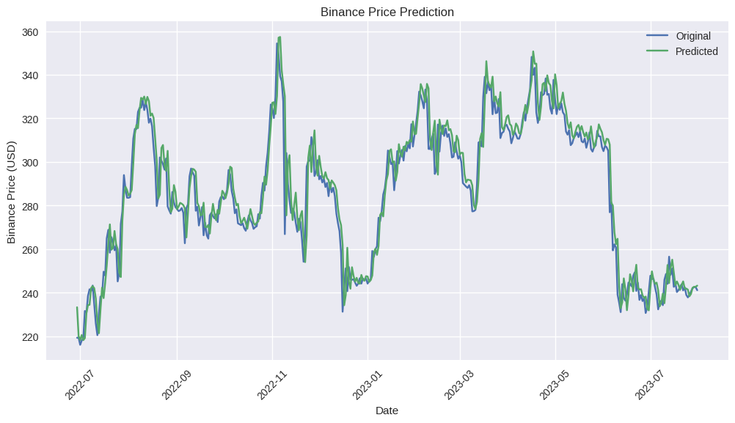
Figure 15. BNB—actual and predicted results using the GRU model.
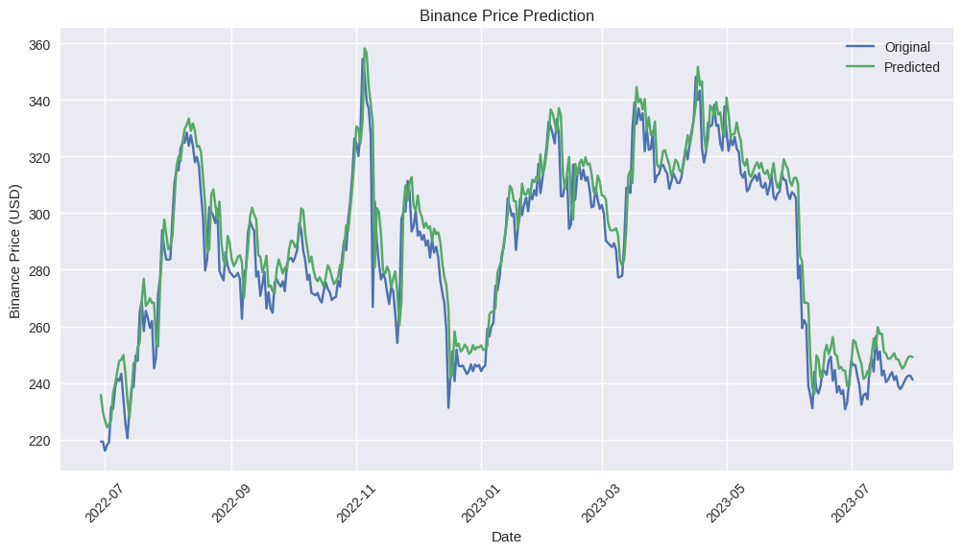
Figure 16. BNB—actual and predicted results using the LSTM model.

4.3. Results for XRP
The assessment of XRP price predictions, as detailed in Table 2 and visually depicted in Figures 17–19, reveals distinctive performance characteristics for the three deep learning models employed.
The Bi-LSTM model emerges as a robust predictor for XRP prices, boasting the lowest RMSE and MAPE values among the three models—RMSE: 0.02 and MAPE: 2.63%. Figure 17 underscores the model's precision, showcasing closely aligned actual and predicted XRP prices, indicating its efficacy in capturing the underlying trends.
The GRU model, while exhibiting slightly higher RMSE and MAPE values compared to Bi-LSTM, still demonstrates notable accuracy in predicting XRP prices (RMSE: 0.03, MAPE: 3.87%). Figure 18 visually confirms the model's proficiency, with minimal disparities between the predicted and actual XRP prices.
The LSTM model, although achieving respectable accuracy, falls slightly behind Bi-LSTM in terms of performance (RMSE: 0.03, MAPE: 2.82%). Figure 19 illustrates the model's predictive capabilities, revealing a satisfactory alignment between the predicted and actual XRP prices.
In summary, the Bi-LSTM model outshines both GRU and LSTM models in forecasting XRP prices, emphasizing its superior performance in capturing the intricate patterns of XRP market trends.
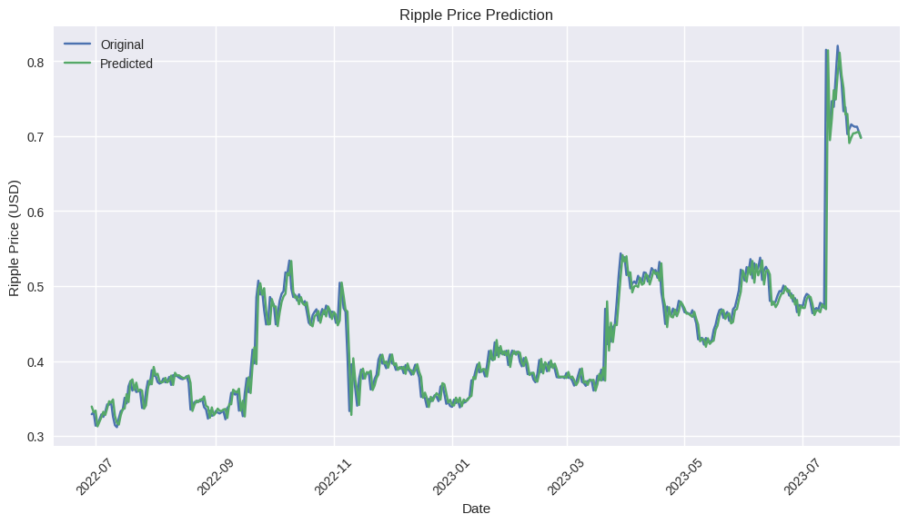
Figure 17. XRP—actual and predicted results using the Bi-LSTM model.
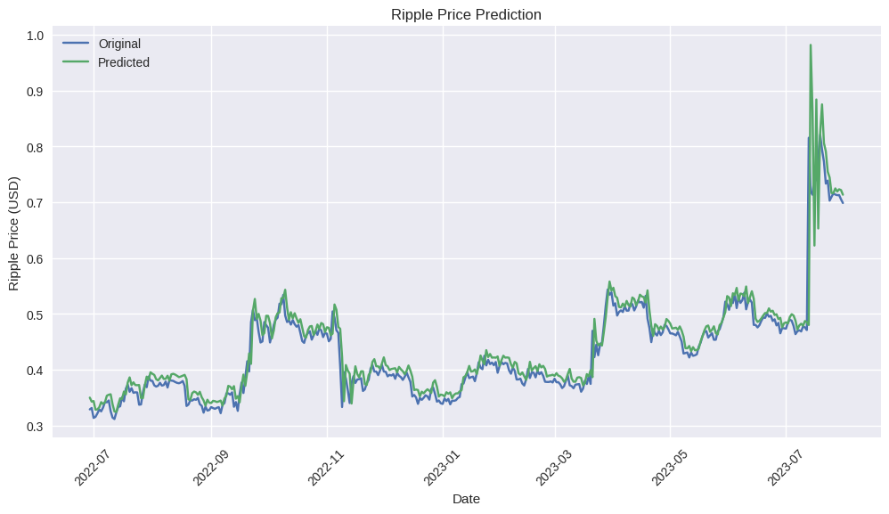
Figure 18. XRP—actual and predicted results using the GRU model.
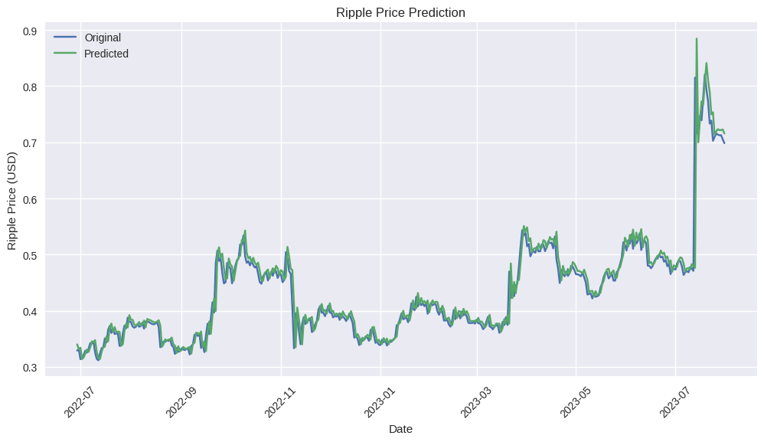
Figure 19. XRP—actual and predicted results using the LSTM model.

5. Discussion
The exploration of deep learning algorithms for cryptocurrency price prediction, focusing on Bitcoin (BTC), Binance Coin (BNB), and Ripple (XRP), has yielded insightful findings. The three employed models—Bi-LSTM, GRU, and LSTM—presented varying degrees of effectiveness in capturing and predicting the intricate dynamics of each cryptocurrency's market.
BTC Predictions:
- The Bi-LSTM model exhibited superior performance, closely followed by the LSTM model.
- Bidirectional RNN networks proved more effective than traditional RNN networks for BTC price prediction.
BNB Predictions:
- The Bi-LSTM model showcased the best performance, demonstrating its accuracy in predicting BNB prices.
- GRU outperformed LSTM, emphasizing the efficacy of bidirectional RNN networks in forecasting BNB prices.
XRP Predictions:
- The Bi-LSTM model demonstrated remarkable accuracy, surpassing both GRU and LSTM in predicting XRP prices.
- Bidirectional RNN networks, particularly Bi-LSTM, emerged as the preferred choice for XRP price forecasting.

6. Conclusion
The study embarked on a comprehensive exploration of deep learning models—Bi-LSTM, GRU, and LSTM—for predicting the prices of three prominent cryptocurrencies. The findings underscored the nuanced nature of cryptocurrency markets, where the efficacy of prediction models varied across different digital assets.
The Bi-LSTM model consistently exhibited superior performance across all three cryptocurrencies, emphasizing its potential as a robust tool for forecasting cryptocurrency prices. The bidirectional nature of Bi-LSTM, capturing both past and future context, proved advantageous in deciphering the intricate patterns inherent in cryptocurrency markets.
While GRU and LSTM models demonstrated respectable accuracy, the results consistently favored bidirectional RNN networks, signifying their relevance and effectiveness in the realm of cryptocurrency price prediction.
In conclusion, the study contributes valuable insights into the dynamic intersection of deep learning algorithms and cryptocurrency markets. The preference for bidirectional RNN networks, particularly Bi-LSTM, provides a foundation for future research and the development of advanced models in the evolving landscape of cryptocurrency analytics.

References
- Melitz, J. DP178 Monetary Discipline, Germany, and the European Monetary System; National Bureau of Economic Research (NBER) Working Paper No. 2319; National Bureau of Economic Research (NBER): Cambridge, MA, USA, 1987. Available online:
https://ssrn.com/abstract=884539 (accessed on 24 September 2022).
- Bulírˇ, A. Income inequality: Does inflation matter? IMF Staff. Pap. 2001, 48, 139–159.
- Basco, S. Globalization and financial development: A model of the Dot-Com and the Housing Bubbles. J. Int. Econ. 2014, 92, 78–94. [CrossRef]
- Nakamoto, S. Bitcoin: A peer-to-peer electronic cash system. Decentralized Bus. Rev. 2008, 21260. Available online: https: //bitcoin.org/bitcoin.pdf (accessed on 19 October 2022) .
- Sureshbhai, P.N.; Bhattacharya, P.; Tanwar, S. KaRuNa: A blockchain-based sentiment analysis framework for fraud cryptocurrency schemes. In Proceedings of the 2020 IEEE International Conference on Communications Workshops (ICC Workshops), Dublin, Ireland, 7–11 June 2020; pp. 1–6.
- Rose, C. The evolution of digital currencies: Bitcoin, a cryptocurrency causing a monetary revolution. Int. Bus. Econ. Res. J. (IBER) 2015, 14, 617–622. [CrossRef]
- Badea, L.; Mungiu-Pupa˘zan, M.C. The economic and environmental impact of bitcoin. IEEE Access 2021, 9, 48091–48104. [CrossRef]
- Vranken, H. Sustainability of bitcoin and blockchains. Curr. Opin. Environ. Sustain. 2017, 28, 1–9. [CrossRef]
- Iwamura, M.; Kitamura, Y.; Matsumoto, T. Is bitcoin the only cryptocurrency in the town? economics of cryptocurrency and friedrich a. hayek. SSRN Electron. J. 2014. [CrossRef]
- Hassani, H.; Huang, X.; Silva, E. Big-crypto: Big data, blockchain and cryptocurrency. Big Data Cogn. Comput. 2018, 2, 34. [CrossRef]
- Hwang, K.; Chen, M. Big-Data Analytics for Cloud, IoT and Cognitive Computing; John Wiley & Sons: Hoboken, NJ, USA, 2017.
- Hitam, N.A.; Ismail, A.R.; Samsudin, R.; Alkhammash, E.H. The Effect of Kernel Functions on Cryptocurrency Prediction Using Support Vector Machines. In Proceedings of the International Conference of Reliable Information and Communication Technology; Springer: Cham, Switzerland, 2022; pp. 319–332.
- Andrianto, Y.; Diputra, Y. The effect of cryptocurrency on investment portfolio effectiveness. J. Financ. Account. 2017, 5, 229–238. [CrossRef]
- Saad, M.; Choi, J.; Nyang, D.; Kim, J.; Mohaisen, A. Toward characterizing blockchain-based cryptocurrencies for highly accurate predictions. IEEE Syst. J. 2019, 14, 321–332. [CrossRef]
- Chowdhury, R.; Rahman, M.A.; Rahman, M.S.; Mahdy, M. An approach to predict and forecast the price of constituents and index of cryptocurrency using machine learning. Phys. A Stat. Mech. Its Appl. 2020, 551, 124569. [CrossRef]
- Derbentsev, V.; Babenko, V.; Khrustalev, K.; Obruch, H.; Khrustalova, S. Comparative performance of machine learning ensemble algorithms for forecasting cryptocurrency prices. Int. J. Eng. 2021, 34, 140–148.
- Chen, W.; Xu, H.; Jia, L.; Gao, Y. Machine learning model for Bitcoin exchange rate prediction using economic and
technology determinants. Int. J. Forecast. 2021, 37, 28–43. [CrossRef]
- Patel, M.M.; Tanwar, S.; Gupta, R.; Kumar, N. A deep learning-based cryptocurrency price prediction scheme for financial institutions. J. Inf. Secur. Appl. 2020, 55, 102583. [CrossRef]
- Wu, C.H.; Lu, C.C.; Ma, Y.F.; Lu, R.S. A new forecasting framework for bitcoin price with LSTM. In Proceedings of the 2018 IEEE International Conference on Data Mining Workshops (ICDMW), Singapore, 17–20 November 2018; pp. 168–175.
- Livieris, I.E.; Pintelas, E.; Stavroyiannis, S.; Pintelas, P. Ensemble deep learning models for forecasting cryptocurrency time-series. Algorithms 2020, 13, 121. [CrossRef]
- Derbentsev, V.; Datsenko, N.; Babenko, V.; Pushko, O.; Pursky, O. Forecasting Cryptocurrency Prices Using Ensembles-Based Machine Learning Approach. In Proceedings of the 2020 IEEE International Conference on Problems of Infocommunications. Science and Technology (PIC S&T), Kharkiv, Ukraine, 6–9 October 2020; pp. 707–712.
- Zhang, Z.; Dai, H.N.; Zhou, J.; Mondal, S.K.; García, M.M.; Wang, H. Forecasting cryptocurrency price using convolutional neural networks with weighted and attentive memory channels. Expert Syst. Appl. 2021, 183, 115378. [CrossRef]
- Ahsan, M.M.; Mahmud, M.P.; Saha, P.K.; Gupta, K.D.; Siddique, Z. Effect of data scaling methods on machine learning algorithms and model performance. Technologies 2021, 9, 52. [CrossRef]
- Hochreiter, S.; Schmidhuber, J. Long short-term memory. Neural Comput. 1997, 9, 1735–1780. [CrossRef]
- Ayoobi, N.; Sharifrazi, D.; Alizadehsani, R.; Shoeibi, A.; Gorriz, J.M.; Moosaei, H.; Khosravi, A.; Nahavandi, S.; Chofreh, A.G.; Goni, F.A.; et al. Time series forecasting of new cases and new deaths rate for COVID-19 using deep learning methods. Results Phys. 2021, 27, 104495. [CrossRef]
- Chung, J.; Gulcehre, C.; Cho, K.; Bengio, Y. Empirical evaluation of gated recurrent neural networks on sequence modeling. arXiv 2014, arXiv:1412.3555.
- Yang, S.; Yu, X.; Zhou, Y. Lstm and gru neural network performance comparison study: Taking yelp review dataset as an example. In Proceedings of the 2020 International Workshop on Electronic Communication and Artificial Intelligence (IWECAI), Shanghai, China, 12–14 June 2020; pp. 98–101.
- Wang, X.; Jiang, W.; Luo, Z. Combination of convolutional and recurrent neural network for sentiment analysis of short texts. In Proceedings of the Proceedings of COLING 2016, the 26th International Conference on Computational Linguistics: Technical Papers, Osaka, Japan, 11–16 December 2016; pp. 2428–2437.
- Dey, R.; Salem, F.M. Gate-variants of gated recurrent unit (GRU) neural networks. In Proceedings of the 2017 IEEE 60th International Midwest Symposium on Circuits and Systems (MWSCAS), Boston, MA, USA, 6–9 August 2017; pp. 1597–1600.
- Schuster, M.; Paliwal, K.K. Bidirectional recurrent neural networks. IEEE Trans. Signal Process. 1997, 45, 2673–2681. [CrossRef]
- Lai, S.; Ye, C.; Zhou, H.J.H. Chinese stock trend prediction based on multi-feature learning and model fusion. In Proceedings of the 2021 IEEE International Conference on Smart Data Services (SMDS), Chicago, IL, USA, 5–10 September 2021; pp. 18–23.
- Singh, A.; Kumar, A.; Akhtar, Z. Bitcoin Price Prediction: A Deep Learning Approach. In Proceedings of the 2021 8th International Conference on Signal Processing and Integrated Networks (SPIN), Noida, India, 26–27 August 2021; pp. 1053–1058.
- Althelaya, K.A.; El-Alfy, E.S.M.; Mohammed, S. Stock market forecast using multivariate analysis with bidirectional and stacked (LSTM, GRU). In Proceedings of the 2018 21st Saudi Computer Society National Computer Conference (NCC), Riyadh, Saudi Arabia, 25–26 April 2018; pp. 1–7.
- Na, Z.; Wang, Y.; Li, X.; Xia, J.; Liu, X.; Xiong, M.; Lu, W. Subcarrier allocation based simultaneous wireless information and power transfer algorithm in 5G cooperative OFDM communication systems. Phys. Commun. 2018, 29, 164–170. [CrossRef]
- Hansun, S.; Wicaksana, A.; Khaliq, A.Q. Multivariate cryptocurrency prediction: Comparative analysis of three recurrent neural networks approaches. J. Big Data 2022, 9, 1–15. [CrossRef]
- Ozturk Birim, S. An Analysis for Cryptocurrency Price Prediction Using Lstm, Gru, and the Bi- Directional Implications. In Developments in Financial and Economic Fields at the National and Global Scale; Cömert, M., S¸ims¸ek, A.E., Eds.; Gazi Kitabevi: Ankara, Türkiye, 2022; pp. 377–392.
- Forecasting Cryptocurrency Prices Using LSTM, GRU, and Bi-Directional LSTM

